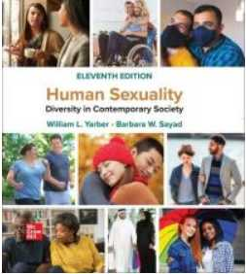
Textbooks
Required reading:
Human Sexuality: Diversity in Contemporary Society by Yarber and
Sayad 11th edition
(loose-leaf version only)
ISBN: 9781266108969
ebook available from VitalSource.com: ISBN: 9781260888584

